Demonstration of Virtualization Using VMware Workstation
1. Aim
To demonstrate virtualization by installing a Type-2 Hypervisor (VMware Workstation) on a host computer and creating and configuring a Virtual Machine (VM) with a Windows/Linux operating system.
2. Procedure
- Download and install VMware Workstation on the host computer.
- Open VMware Workstation after installation.
- Click on Create a New Virtual Machine.
- Select the installer ISO file of Windows/Linux.
- Enter the virtual machine name and choose its storage location.
- Allocate RAM, processor cores and virtual hard disk space.
- Configure the virtual machine settings.
- Click Finish to create the VM.
- Click Power On to start the virtual machine.
- Install the guest operating system by following the on-screen instructions.
- Verify that the operating system runs successfully
Implementation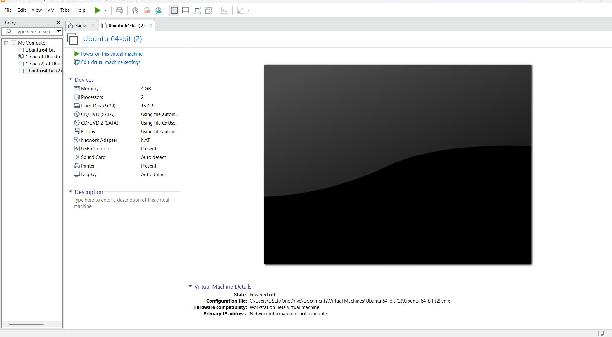

Result
Thus, virtualization was successfully demonstrated using VMware Workstation (Type-2 Hypervisor) by creating and configuring a Virtual Machine and installing a Windows/Linux operating system.

